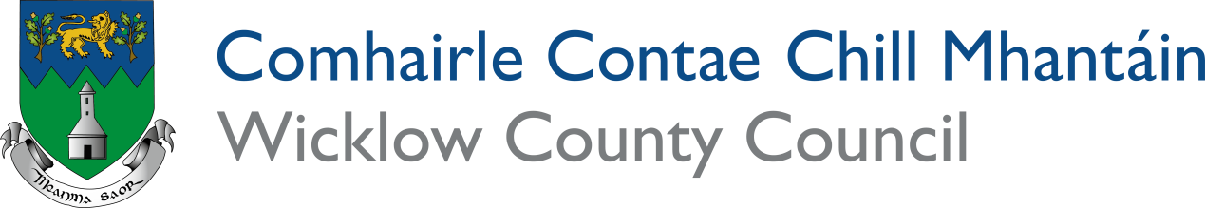

SUSTAINABLE DEVELOPMENT AWARDS 2026

SUSTAINABLE DEVELOPMENT AWARDS

The aim of the Sustainable Development Awards is to showcase best practice in environmental protection and sustainable development in harmony with our environment across County Wicklow. Through the awards, we aim to recognise the diverse range of groups engaged in environmental awareness projects. The competition is open to any group working at local level, which has undertaken a project that demonstrates good practice.

The awards have links to best practice in the National Tidy Towns Competition which aims to help us build more sustainable communities and to delivery on the Sustainable Development Goals. They are open to all types of community groups including Tidy Towns groups, Coastcare groups, sports and recreational clubs, schools, local businesses, housing estates and rural communities.

These awards aim to recognize some of the great work and innovative ideas being developed to make Wicklow more resilient to Climate Change and protect our natural resources and biodiversity. Communities across the county are key partners in delivering action on both mitigation and adaptation in relation to Climate Change and also the protection of biodiversity at local level. Wicklow County Council would like to recognize your contribution.

Details of your entry can be submitted either on the form below, or by submitting additional documents detailing projects, noting which categories of award you wish to have considered on this form.

In any given year awards may not be given for all categories. An award will only be made where Wicklow County Council believes that the works undertaken are of high value as an example to all in County Wicklow. Where justified, due to quality or difference in type of action, a second recognition may also be given in an award category.

THE AWARDS ARE OPEN TO ALL RELEVANT TOWNS, VILLAGES AND COMMUNITY GROUPS, SCHOOLS AND ORGANISATIONS IN COUNTY WICKLOW.

Closing date for receipt of completed applications:
General closing date is Friday 3rd of July 2026
For schools: Friday 11th September

For further details please contact Environmental Awareness Office
(0404) 20236 or email eao@wicklowcoco.ie

Completed forms should be returned to the Environmental Awareness Office.
Entries can be sent by email to eao@wicklowcoco.ie or by post to The Environmental Awareness Office, Wicklow County Council, Station Road, Wicklow, Co. Wicklow A67 FW96. Email entries are preferred.

Name of Group/Organisation:

Contact Name:

Address:

Telephone:

Email:

Treasurer’s Name:
Treasurer Email:

Please complete the box(es) with information on work that your COMMUNITY has undertaken. FILL IN A SEGMENT FOR THE AWARD(S) THAT YOU WISH TO APPLY FOR.
You may apply for one, several or all awards but ensure that you fill in or provide information for each one that you wish to enter. We would also like to have your actions mapped on Wicklow’s SDG map. Visit www.wicklow.ie/Living/Your-Council/Climate-Action-and-Biodiversity/Sustainable-Development-Goals to upload an action or view the map.

Please ensure that you give adequate details of the project, how it was undertaken and how it will proceed into the future. Please include photos and maps where suitable. Give as much detail as possible.

IMPORTANT NOTE: For the competition, all entries must have an associated bank account if awarded. This is required to receive payments from the finance department of Wicklow County Council. Please note that bank details cannot belong to a private individual and must be in the name of the group, business, school or organisation that is applying. Any deviations from this will require official letter of justification from the applicant. We will contact you to confirm all details if you have been successful.

PLEASE TICK WHICH AWARD CATEGORY YOU WISH TO APPLY FOR:

Biodiversity, Wildlife and Natural Amenities Award
Projects may include measures taken to protect species or increase the number of species in an area, habitat creation or management, wildlife gardening, demonstration areas. It may include awareness raising projects among local people, including signs, leaflets, etc. Projects can link to SDG 14 Life Below Water or SDG 15 Life on Land.
Built Environment Award
The built environment includes buildings both in use or derelict, heritage sites, roads, bridges, walls or any man-made ‘built’ area. Project can centre on their protection, preservation, maintenance or repair. Projects that interpret or increase awareness on built heritage are also covered.
Business Award
Recognizing best practice of a business that engages with the local community in developing sustainable communities or implements best practice or innovation for sustainability in its own activities. Nomination of a business that has done good work at local level is sought. Businesses may be delivering on SDG 8 Decent Work and Economic Growth, SDG 9 Industry Innovation and Infrastructure, SDG 11 Sustainable Cities and Communities or SDG 12 Responsible Consumption and Production.
Climate Change Award
Recognition for a project undertaken that help to improve our understanding of Climate Change, mitigates against Climate Change or helps us to build local resilience and adapt to Climate Change. Can be a school, business or community based project. Can focus on energy consumption, travel, carbon sequestration or nature based resilience. Delivering on SDG 13 Climate Action.
Coast Care Award
Recognition for established and new groups working in coastal areas that carry out measures to enhance and protect their local coastal areas. May include beach management or educational and awareness raising initiatives. Project and actions will deliver on SDG 14 Life Below Water.
Communal Gardening Award
Recognition for the communal gardening groups in the county. These may be community gardens or allotments or any type of communal gardening where people get together to grow. Should deliver on SDG Partnership for the Goals, SDG 12 Sustainable Consumption and Production and SDG 11 Sustainable cities and communities.
Energy Award
Recognition for effort to promote better use of energy in the community either through energy planning, efficiency measures or use of renewables. Projects can raise awareness and promote engagement by the wider community to tackle Climate Change through use of energy. Entries from Sustainable Energy Communities welcome. Delivering on SDG 7 Affordable and Clean Energy.
Sustainable Food Award
Best practice in promoting the use of local produce, sustainable production or Fairtrade. Can be a business, farm enterprise, community or school based project. Can be a nomination of a local producer who is advancing market development for innovative local produce. Delivering on SDG 11 Sustainable cities and Communities, SDG 10 Reduced inequalities SDG 8 Decent work and Economic Growth and SDG 9 Industry, Innovation and Infrastructure.
Landscaping Award
Landscaping plays an important role in enhancing our communities. This should be projects that enhanced the local landscape and may be hard or soft landscaping or a combination of both. It should demonstrate best environmental practice using native planting and trees where possible and consideration for pollinators. Can also consider resource consumption in creation and maintenance. Projects can demonstrate consideration for SDG 15 Life on Land, SDG 13 Climate Action, SDG 11 Sustainable Cities and Communities and SDG 6 Clean Water and Sanitation.
Local Champion
Recognition to an individual who has played a key role in protecting local environments or leading a local campaign to protect our environment. Champions should help to deliver SDG 17 Partnerships for Goals. This award is by nomination.
Farming Champion
Recognition for a farm that is a leading example of the work being undertaken by the farming community to deliver a more sustainable future for the farming sector including climate action, restoration of biodiversity or protection of natural resources such as water.
Schools Awareness Award
Identifying best practice on sustainability education in our schools. Schools are invited to submit details of any environmental awareness project undertaken in the last year that engages students or the wider population in an innovative way. Projects can address an environmental issue at local level or help to engage people through awareness and advocacy. Can be focused on any of the SDGs.
Schools Biodiversity Award
This award recognises the special role that schools play in promoting awareness and developing understanding of biodiversity. It can be for a project in class or across the whole school, an outdoor activity or involvement in a campaign. Projects should focus on SDG 14 Life Below Water or SDG 15 Life on Land.
Schools Climate Change Award
This award recognises the special role that schools play in promoting awareness and developing understanding on Climate Change. It can be for a project in class, an outdoor activity or involvement in a campaign on Climate Action. It can be an innovation undertaken to make the school more climate resilient. Project will deliver on SDG 13 Climate Action.
Sustainable Tourism/Recreation Award
Recognition of community based projects, greening of events or businesses implementing best practice in the tourism and recreation sector. Can involve protection of natural resources or a focus on improving resource efficiency in tourism and recreational activities. This deliver on a range of SDGs including SDG 8 Decent Work and Economic Growth, SDG 11 Sustainable Cities and Communities, SDG 12 Responsible Consumption and Production
Trees Award
Identifying best practice in the planting or care of trees. A project that demonstrates how trees can be incorporated into our communities or how good maintenance can be used to ensure their continued service to our local environment and community. Should include native or pollinator friendly trees. Projects deliver on SDG 15 Life on Land.
Youth Environmental Champion Award
Recognition to an individual under the age of 25 who has played a key role in protecting local environments, active participation in a project or leading a local campaign to protect our environment.
Waste Minimisation Award
Actions that deliver on waste prevention and shifting focus to a circular economy based on reducing waste through preventing waste in the first place, Reduce what we do create, Reuse what we can, Recycle what is possible and make sure even the recycling bin is smaller!
SDG 12 Responsible consumption is the primary goal for this award.
Water Award
Identifying best practice in protection of our waterways or water conservation. Can involve projects to improve water quality, assist biodiversity, citizen science or raise awareness on protecting our waterways. Projects or campaigns that help to reduce our consumption of water in our communities, homes or businesses. Delivers on SDG Life Below Water and SDG 6 Clean Water and Sanitation.

Remember

Closing date for Groups: Friday 3rd July 2026

Closing date for Schools Awards: Friday 11th of September 2026

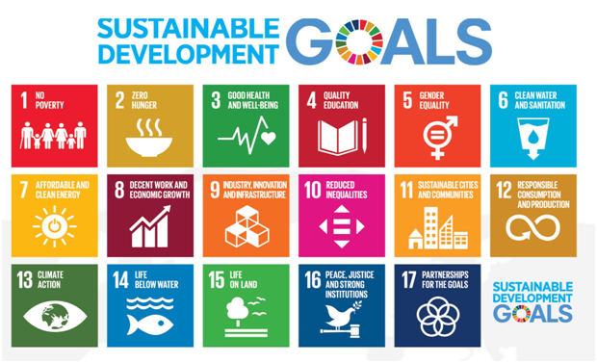

Category_________________________________________________

Tidy Towns Groups can submit their application for the National Competition rather than filling out this section. We would also welcome the listing of your projects on our Sustainable Development Goals for Wicklow map. https://www.wicklow.ie/Living/Your-Council/Climate-Action-and-Biodiversity/Sustainable-Development-Goals

Details of project or action:

Category_________________________________________________

Tidy Towns Groups can submit their application for the National Competition rather than filling out this section. We would also welcome the listing of your projects on our Sustainable Development Goals for Wicklow map.. https://www.wicklow.ie/Living/Your-Council/Climate-Action-and-Biodiversity/Sustainable-Development-Goals

Details of project or action:

Category_________________________________________________

Tidy Towns Groups can submit their application for the National Competition rather than filling out this section. We would also welcome the listing of your projects on our Sustainable Development Goals for Wicklow map.. https://www.wicklow.ie/Living/Your-Council/Climate-Action-and-Biodiversity/Sustainable-Development-Goals

Details of project or action:

PLEASE COPY AND PASTE FURTHER DIALOGUE BOXES AS NEEDED IF ENTERING SEVERAL CATEGORIES

