

TIDY ESTATES 2026

TIDY TOWNS SUSTAINABLE DEVELOPMENT COMPETITION

CATEGORY: HOUSING ESTATES

General Appearance, Absence of Litter, Maintenance of Open Space, Management of Biodiversity, Waste Prevention, Work undertaken to improve the estate. Linkages with Tidy Towns, Delivery of the SDGs.
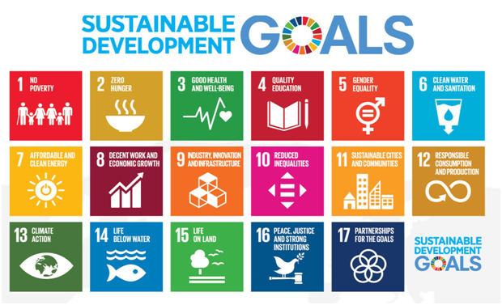

Closing date for receipt of applications is the Friday 3rd of July 2026.

IMPORTANT NOTE: For the competition, all entries must have an associated bank account if awarded. This is required to receive payments from the finance department of Wicklow County Council. Please note that bank details cannot belong to a private individual and must be in the name of the group, business, school or organisation that is applying. Any deviations from this will require official letter of justification from the applicant. We will contact you to confirm all details if you have been successful.

Name of Estate:
Contact Name:
Address:
Telephone:
Email:
Treasurer Name:
Treasurer email:
Local Tidy Town Group:

Please give details of how you have managed your estate.

This should include clean ups, improvement works, plantings, community involvement, challenges overcome, any other projects you feel are relevant and any interaction with Tidy Towns or other groups.
Reference any SDGs your work has delivered on. If you have a photo of an event or area you are particularly proud of and want to draw attention to, please include it in your submission.

The Tidy Estates competition will be judged on the following criteria:

- General tidiness and lack of litter or dumping.
- Planted areas, maintenance, community effort, and suitability, particularly management of Biodiversity.
- General appearance of the estate including upkeep of the houses.
- Work carried out since last year. There should be on-going improvement work. Winning estates should be demonstrating work undertaken to improve the estate over the year.
- Work carried out as a community effort, residents working together to make the estate better rather than depending on outside help or just one household.
- Consideration for resources and finances available to the residents.
- Consideration for length of time the estate has been established.
- Linkage to the Local Tidy Towns and other groups.
- Please use more paper if needed.
- A photo is always welcome

For judging, estates to be visited will be shortlisted based on the information supplied in the application.

For further details/explanations please contact Environmental Awareness Office or your local Tidy Towns Committee.
(0404) 20236 or email eao@wicklowcoco.ie

Application can be posted to the below address but waste free applications by email are preferred. Send to eao@wicklowcoco.ie on or before Friday July 3rd 2026.

Good Luck.

Environmental Awareness Office
Wicklow County Council
Station Road
Wicklow Town
Co. Wicklow
A67 FW 96

